**Test Case** **0046**

**System:** VirtuCardsClient

**Description:** Test to ensure that a client can select a new Avatar

**Severity:** 3

**Instructions**

**Test 1**

1. Start VirtuCardClient application
2. Click the button labeled “Sign In”
3. Enter “test@test0.com” into the text input labeled “Enter email…”
4. Enter “Password!123” into the text input labeled “Enter password…”
5. Press the button labeled “Login”
6. A window should appear saying “Login Success”
7. Press the OK button that appears on that window
8. Click the Profile icon located in the top left of the screen.
9. Click the button labeled “Edit Avatar”
10. Click the button labeled “Upload Custom”
11. Select an image from the device as the new Avatar.

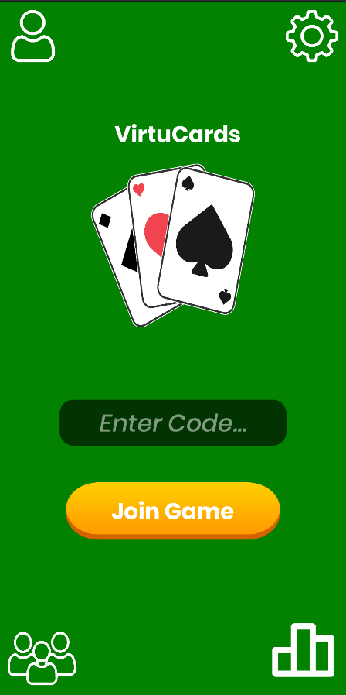**Expected Result:** The profile page should show the chosen image as the Avatar

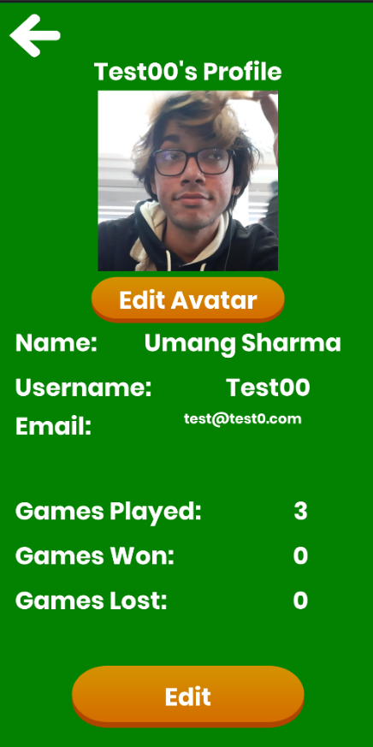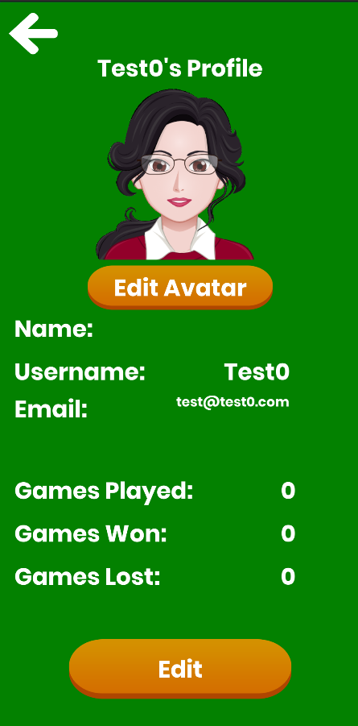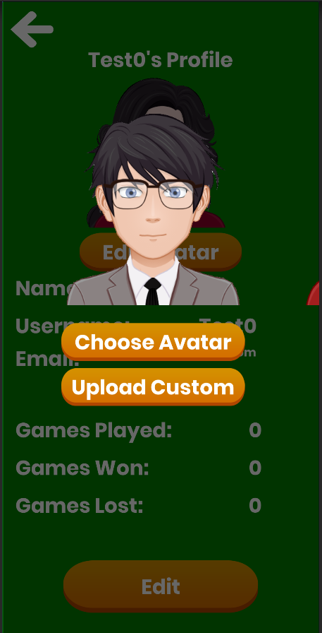

The above images outline the steps mentioned in choosing a new Avatar after logging in. The first image is the screen displayed after logging in; the second image is the profile screen viewed after clicking the profile icon; the third image is the ‘Choose Avatar’ screen seen after clicking the button of the same name; and the fourth image is the profile screen after selecting a new avatar.

**Test 2**

1. Start VirtuCardClient application
2. Click the button labeled “Google Sign In”
3. Choose a Google account you would like to sign-in with.
4. Click the Profile icon located in the top left of the screen.
5. Click the button labeled “Edit Avatar”
6. Click the button labeled “Upload Custom”
7. Select an image from the device as the new Avatar.

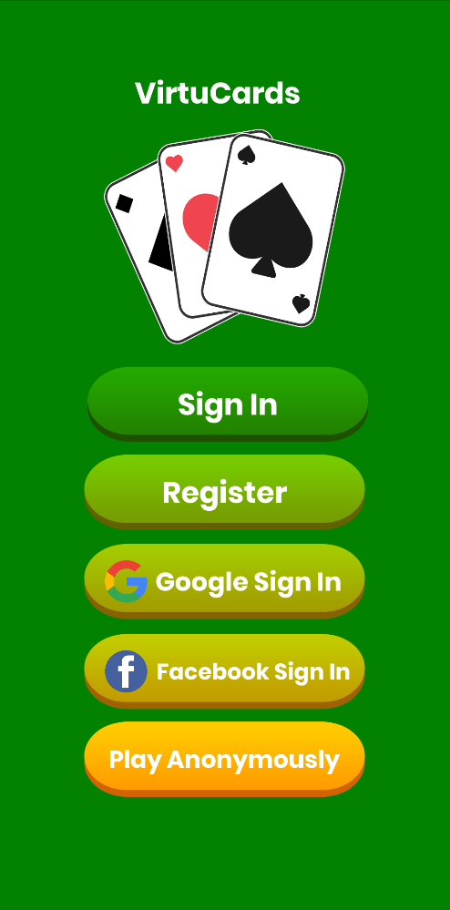**Expected Result:** The profile page should show the chosen image as the Avatar

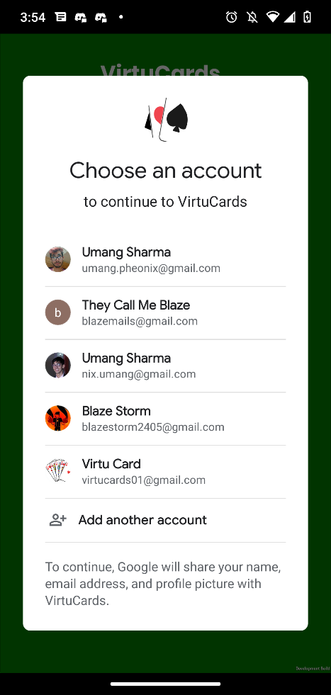

The Join Code screen will load after the user chooses their desired Google account. Click the Profile Screen icon in the top left.

The above image displays the screen after the user presses the Google Sign in button. Choose your desired account from the ones displayed on your screen. The accounts above are examples

The above image displays the landing page. The Google Sign in button is highlighted as this is the sign-in method used in this test.

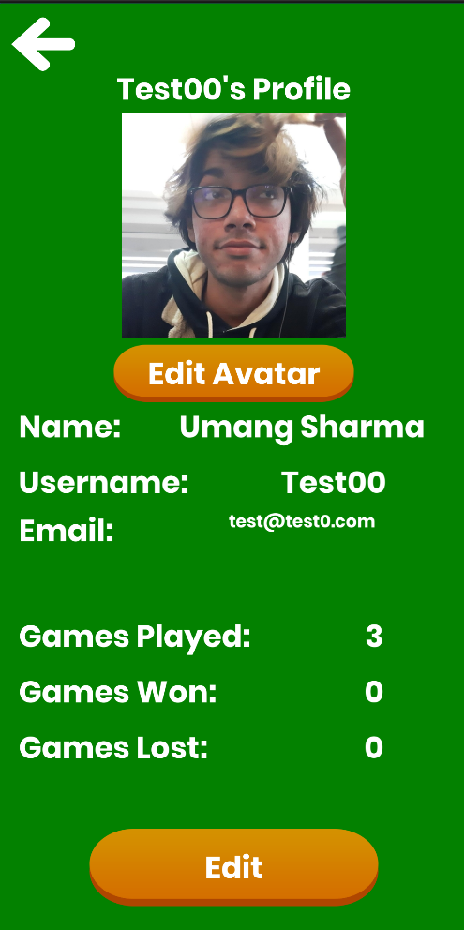

The Expected Result is that the chosen Avatar is shown above the Edit Avatar button now.

Click the button labeled Upload Custom and choose an image from the device as the new Avatar.

The above image displays the Profile Screen. Click the Edit Avatar button.

**Test 3**

1. Start VirtuCardClient application
2. Click the button labeled “Sign In”
3. Enter “test@test0.com” into the text input labeled “Enter email…”
4. Enter “Password!123” into the text input labeled “Enter password…”
5. Press the button labeled “Login”
6. A window should appear saying “Login Success”
7. Press the OK button that appears on that window
8. Click the Profile icon located in the top left of the screen.
9. Click the button labeled “Edit Avatar”
10. Click the button labeled “Upload Custom”
11. Select an image from the device as the new Avatar.
12. Close the application
13. Start another instance of the VirtuCardClient application
14. Repeat Steps 1-8.

**Expected Result:** The profile page should show the chosen image as the Avatar after restarting the application.



The new Avatar should be shown now above the Edit Avatar button.

Click the button labeled Upload Custom and choose an image from the device as the new Avatar.

Click the Edit Avatar button on the Profile screen to change the avatar.

******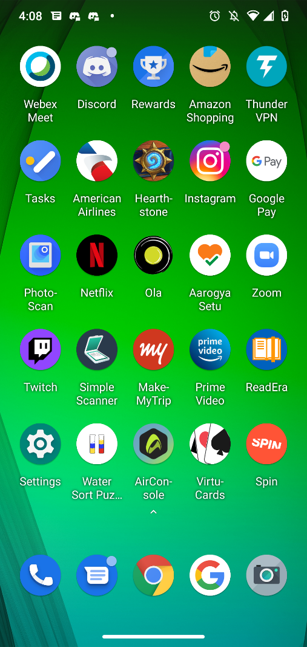**

The Profile Screen should display the chosen Avatar now.

Click the Profile Icon in the top left screen.

Restart the VirtuCardsClient application, and sign-in using the credentials mentioned above.

Close the VirtuCards application.

**Test 4**

1. Start VirtuCardClient application
2. Click the button labeled “Google Sign In”
3. Choose a Google account you would like to sign in with.
4. A window should appear saying “Login Success”
5. Press the OK button that appears on that window
6. Click the Profile icon located in the top left of the screen.
7. Click the button labeled “Edit Avatar”
8. Click the button labeled “Upload Custom”
9. Select an image from the device as the new Avatar.
10. Close the application
11. Start another instance of the VirtuCardClient application
12. Repeat Steps 1-6.

**Expected Result:** The profile page should show the chosen image as the Avatar after restarting the application.



Click the profile icon in the top left of the screen.

Choose your desired Google account.

Click the Google Sign In button on the landing page.

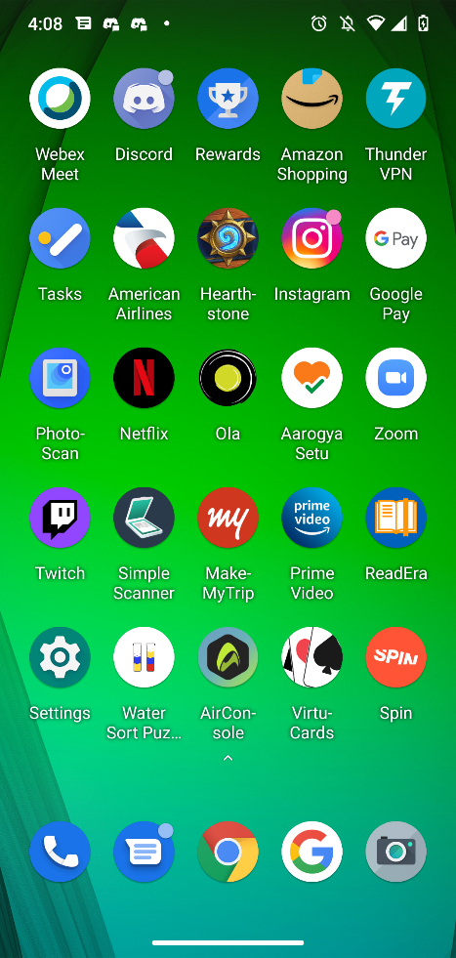

Click the profile icon in the top left of the screen.

Restart the application and click the Google Sign In button.

Close the application.

The chosen avatar should now be displayed on the profile screen.

Click the button labeled Upload Custom and choose an image from the device as the new Avatar.

Click the Edit Avatar button.



The chosen Avatar should be displayed in the profile screen still.

**Test 5**

1. Start VirtuCardClient application
2. Click the button labeled “Play Anonymously”
3. Click the Profile icon located in the top left of the screen.
4. Click the button labeled “Edit Avatar”

**Expected Result:** There should be an Error panel that should not allow the user to change their Avatar

****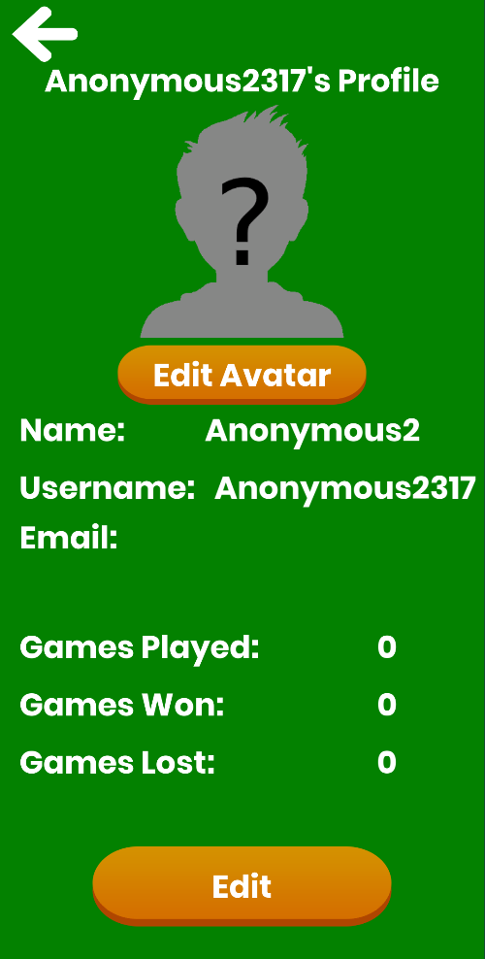****

Click the Edit Avatar button.

Click the Profile Icon on the top left of the Join Code screen.

Click the Play Anonymously button.

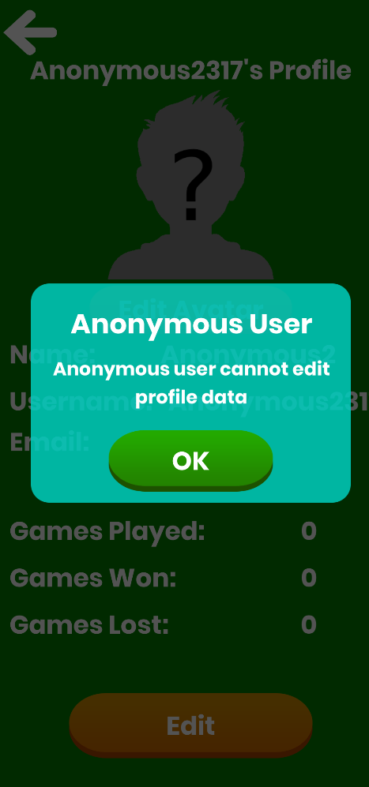

The Expected Result is an Error panel that says Anonymous users cannot edit their profile data.